Project Development - Delivery Of Sprint-4

|  |  |
| --- | --- |
| Date | 15-11-2022 |
| Team ID | PNT2022TMID12351 |
| ProjectName | Project-IoT Based Safety Gadget For  Child Safety Monitoring &  Notification |
| MaximumMarks |  |

WEB USER INTERFACE

FIREOUTH.HTML HTML,CSS AND JS CODE:

<!DOCTY

PE html>

<html lang="en">

<head>

<meta charset="UTF-8">

<meta name="viewport" content="width=device-width, initial-scale=1.0">

<link rel="stylesheet" href="/FIREOAUTH.css">

<link rel="stylesheet" href="https://cdnjs.cloudflare.com/ajax/libs/nprogress/0.2.0/n progress.min.css">

<link rel="shortcut icon" href="https://raw.githubusercontent.com/tharunoptimuspd/firepwa/main/favicon.ico?token=GHSAT0AAAAAABR46 HVJ5M5L3QGFRZRQXOISYUJUWAA" type="image/xicon">

<style> html, body {

height: 100%; margin: 0;

font-family: -apple-system, BlinkMacSystemFont,

"Segoe UI", Roboto, Oxygen,

Ubuntu, Cantarell, "Open Sans", "Helvetica Neue",

sans-serif; font-weight: 300;

}

a {

text-decoration: none; color: #007bff; font-weight: 500; font-size: 1.2rem;

}

h3 {

font-size: 1.4rem;

}

h3, h4 {

margin: 0; padding: 0.3rem 0;

}

.wrapper { display: flex; flex-direction: column; align-items: center; justify-content: center; height: 100%; text-align: center;

}

.oneClickSignin { padding: 0.5rem; border: 1px solid #44444444; border-radius: 5px; box-shadow: 0 0 3px 0px #44444444; opacity: 0.2; pointer-events: none;

}

.qrcode { opacity: 0.1;

}

.learnAboutFire { padding-top: 1.25em;

}

.qrHolder { display: none;

margin-top: 3rem;

}

.qrContainer { align-items: center; display: flex; justify-content: center; padding: 8px; margin: 2rem auto; box-shadow: 0 0px 6px 1px rgb(0 0 0 / 16%); border: 1px solid #44444444; border-radius: 6px; width: 200px; height: 200px;

}

</style>

<title>Fire OAuth</title>

<script> if (window.location.hostname !== "localhost") {

if (location.protocol !== "https:") { location.replace(

`https:${location.href.substring( location.protocol.length

)}`

)

}

}

</script>

</head>

<body>

<div class="wrapper">

<h3 class="pageTitle">Login with SAFETY</h3>

<div class="qrAuthorize">

<h4 class="subTitle">Scan QR from your Fire OAuth App</h4>

<div class="qrContainer">

<canvas id="qr-code" class="qrcode"></canvas>

</div>

</div>

<div class="oneClickSignin">

<h4>Have Fire PWA on this device?</h4>

<a target="_blank" id="authorizeOverLink" href="https://firepwa.netlify.app/authorize?sessionId" rel="noopener">Click to Authorize </a>

</div>

<div class="learnAboutFire">

<a target="_blank" href="https://fireoauth.netlify.app" rel="noopener">Learn

More about SAFETY</a>

</div>

</div>

<script src="https://cdnjs.cloudflare.com/ajax/libs/nprogress/0.2.0/n progress.min.js"></script>

<script src="https://cdnjs.cloudflare.com/ajax/libs/qrious/4.0.2/qriou s.min.js"></script>

<script src="https://cdnjs.cloudflare.com/ajax/libs/socket.io/4.2.0/soc ket.io.js"></script>

<script>

const FIRE_API_KEY = "635b790a3bcc6b59c4b772d0"

const FIRE_ENDPOINT =

"https://fire.adaptable.app/api/apis/generate"

const CHANNEL_NAME = "fireOAuthChannel" const broadCastingChannel = new

BroadcastChannel(CHANNEL_NAME) const FIRE_SERVER_SOCKET_ENDPOINT =

"https://fire.adaptable.app"

let socket = io(FIRE_SERVER_SOCKET_ENDPOINT)

let qr

let qrcode = document.querySelector(".qrcode") let oneClickSignin =

document.querySelector(".oneClickSignin") let pageTitle = document.querySelector(".pageTitle") let subTitle = document.querySelector(".subTitle")

function setOpacity(opacity) {

oneClickSignin.style.opacity = opacity

oneClickSignin.style.pointerEvents = opacity ===

"1" ? "auto" : "none"

qrcode.style.opacity = opacity

}

async function getSessionID() {

let response try {

response = await

fetch(`${FIRE_ENDPOINT}/${FIRE_API_KEY}`, { method: "GET", headers: {

"Content-Type": "application/json",

}

})

} catch (error) { console.log(error) return null

}

let data = await response.json() let { sessionId, chatRoomId } = data

return { sessionId, chatRoomId }

}

function generateQR(value) {

(qr = new QRious({ element: document.getElementById("qr-code"), size: 200, level: 'M',

value: value,

}))

}

function changeHREF ({sessionId, chatRoomId}) {

let firePwaUrlHostname =

"https://firepwa.netlify.app" let originURL =

encodeURIComponent(window.location.origin)

let url =

`${firePwaUrlHostname}/authorize.html?sessionId=${session

Id}&chatRoomId=${chatRoomId}&url=${originURL}` let a =

document.getElementById("authorizeOverLink")

a.href = url }

async function fire() { NProgress.set(0.4)

let { sessionId, chatRoomId } = await getSessionID()

if(sessionId === undefined || chatRoomId ===

undefined || sessionId === null || chatRoomId === null) { pageTitle.innerHTML = "Something went wrong

"

subTitle.innerHTML = "Please try again later " return }

setOpacity("1")

NProgress.done() let data = {

sessionId,

url: encodeURIComponent(window.location.origin)

}

data = JSON.stringify(data) generateQR(data) changeHREF({sessionId, chatRoomId}) socket.emit("join room", sessionId)

}

fire()

socket.on("trusted token", (token) => {

let data = {} data.success = true data.token = token

broadCastingChannel.postMessage(data)

window.close()

})

</script>

</body>

</html>

OUTPUT:

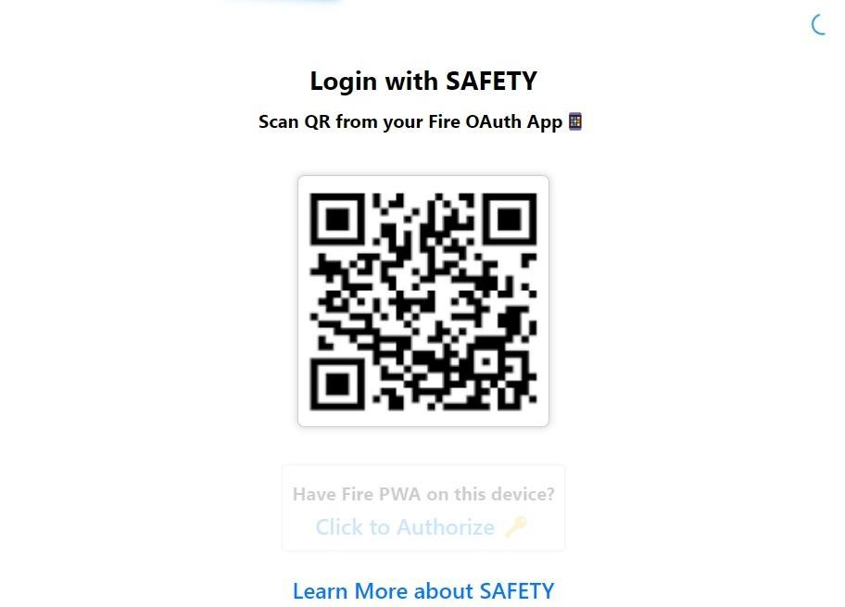

OUTPUT: AFTER CLICKING LEARN MORE ABOUT SAFETY

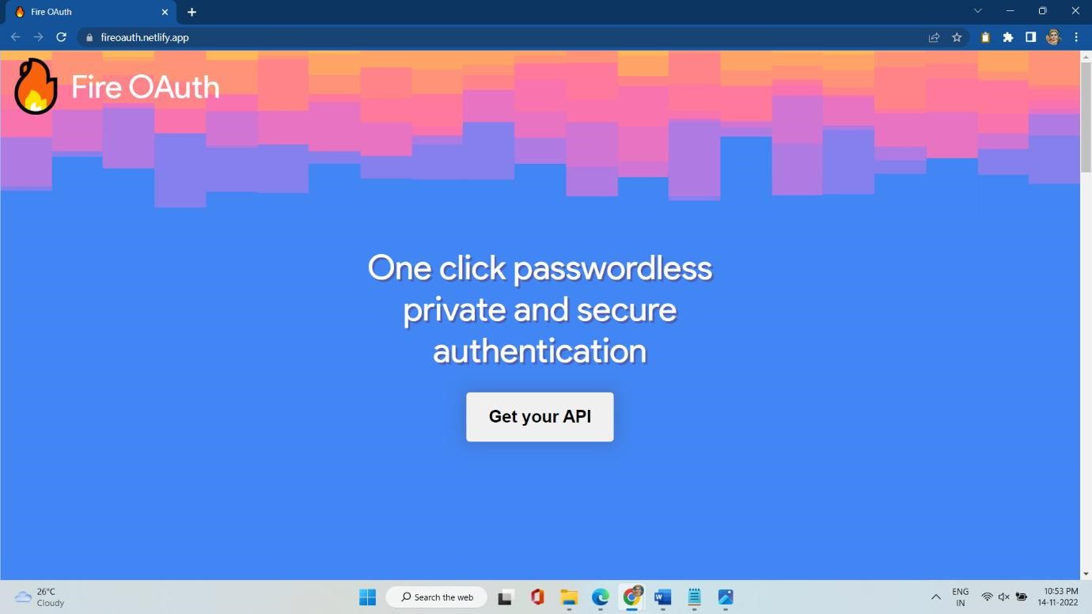

GEOFENCE NODE:

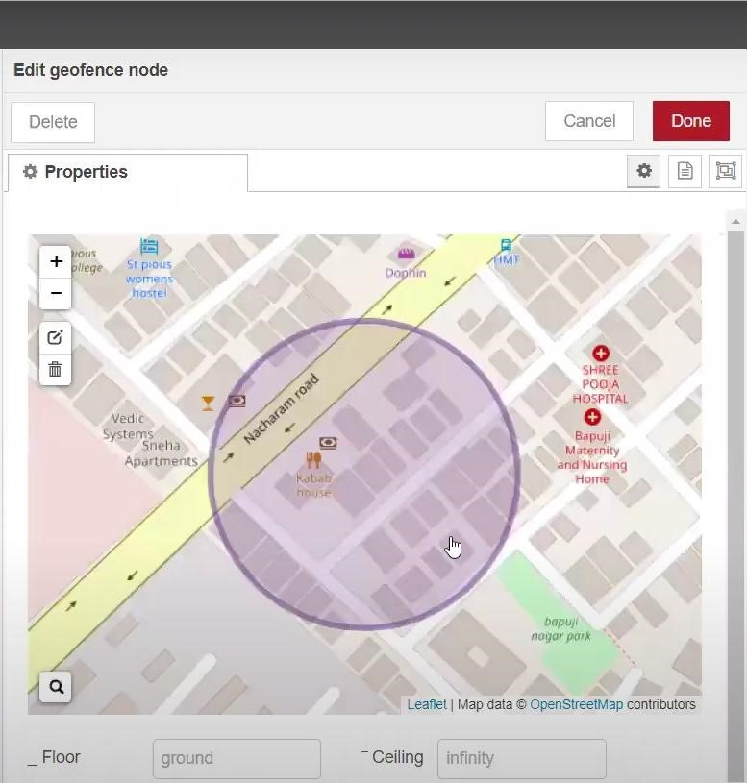

LOCATION:

After running the script, the web UI shows “Child is not in the particular area”

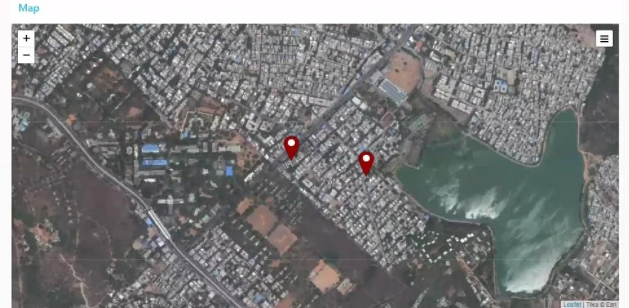

Result: successfully completed.